Lab 1：MATLAB Programming

Authors | Name：何衍宁 Student ID:12311512  Name：夏天 Student ID:12311610
Objective
1.4
Understand how to demonstrate when a system does or does not satisfy a given property. Use MATLAB to construct such counterexamples for a variety of systems and properties.

1.5
Write a function which implements the first-order autoregression equation. Use MATLAB to test and analyze the function on some example systems.

Lab results & Analysis
1.4
Basic Problems
For these problems, you are told which property a given system does not satisfy, and the input sequence or sequences that demonstrate clearly how the system violates the property. For each system, define MATLAB vectors representing the input(s) and output(s). Then, make plots of these signals, and construct a well reasoned argument explaining how these figures demonstrate that the system fails to satisfy the property in question.

1.4a (linearity)
(a). The system y [n] = sin((π/2)x[n]) is not linear. Use the signals xl [n] = δ[n] and x2[n] = 2δ[n] to demonstrate how the system violates linearity.
The problem requires to prove the system y[n] = sin((π/2)x[n]) violates linearity by using the unit impulse function δ[n].
Analysis:
In signal processing, linear systems satisfy two basic properties: Additivity and Homogeneity. If a system does not satisfy these two properties, then it is nonlinear. To prove the system y[n] violates linearity, we can use the unit impulse function δ[n] to test whether the system satisfies additivity. Let x_combined = x1+x2, compare y1+y2 with y_combined , if y1+y2 ≠ y_combined, then it is non-linear, so plot y1+y2 and compare the signal image with y_combined, and make difference between y1+y2 and y_combined :
clear;
clc;
% 定义时间范围
n = -10:10; % 时间序列
% 创建输入信号 x1[n] = delta[n] 和 x2[n] = 2*delta[n]
x1 = zeros(size(n));
x2 = zeros(size(n));
x1(n == 0) = 1;
x2(n == 0) = 2;
% 系统响应
y1 = sin(pi/2 * x1);
y2 = sin(pi/2 * x2);
% 计算组合输入和对应的输出
x_combined = x1 + x2; % 输入的组合
y_combined = sin(pi/2 * x_combined); % 组合输入的响应
% 叠加输出
y_sum = y1 + y2; % 单独响应的和
% 绘制图形
figure;
subplot(3,1,1);
stem(n, y_combined, 'filled');
title('System Response to Combined Input x1[n] + x2[n]');
xlabel('n');
ylabel('y[n]');
subplot(3,1,2);
stem(n, y_sum, 'filled');
title('Sum of Individual Responses y1[n] + y2[n]');
xlabel('n');
ylabel('y[n]');
subplot(3,1,3);
stem(n, y_combined - y_sum, 'r', 'filled');
title('Difference Between Combined Response and Sum of Responses');
xlabel('n');
ylabel('Error y[n]');
% 显示所有图形
figure(gcf);
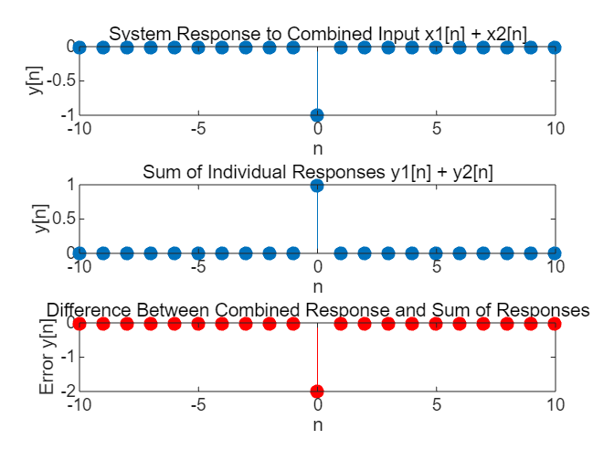
Lab result:
Since y1+y2 ≠ y_combined, the system is not linear.

1.4b (causality)
The problem requires that the unit step function be used to prove that the system y[n] = x[n] + x[n+1] violates causality.
(b). The system y[n] = x[n] + x[n + 1]is not causal. Use the signal x[n] = u[n] to demonstrate this. Define the MATLAB vectors x and y to represent the input on the interval -5 <= n <= 9, and the output on the interval -6 <= n <= 9, respectively.
Analysis:
In signal processing, causality refers to the property of a system where the output at any given time depends only on the current and past inputs, not on future inputs. we can examine the system’s response to a unit step function input x[n] = u[n]. Let n=0, since y[0]=x[0]+x[1], draw x[n] and y[n] images for comparison:
% 定义信号
n = -5:9;
x = [zeros(1,5), ones(1,10)]; % u[n]
y = [zeros(1,4),1,2,2,2,2,2,2,2,2,2,2];

% 绘制信号
figure;
subplot(2,1,1);
stem(n, x);
title('x[n] = u[n]');
subplot(2,1,2);
stem(n, y);
title('y[n] = x[n] + x[n+1]');

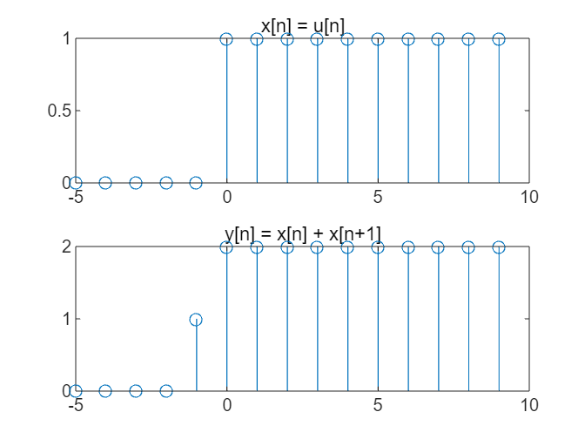
Lab result:
Since the value of y[0] is related to the value of x[1], the requirement of causality is not satisfied.

1.4c (stable)
They want to prove that y[n] = log(x[n]) is unstable.
(c). The system y[n] = log(x[n]) is not stable.
Intermediate Problems
For these problems, you will be given a system and a property that the system does not satisfy, but must discover for yourself an input or pair of input signals to base your argument upon. Again, create MATLAB vectors to represent the inputs and outputs of the system and generate appropriate plots with these vectors. Use your plots to make a clear and concise argument about why the system does not satisfy the specified property.
Analysis:
To prove that the system y[n] = log(x[n]) is unstable, we need to demonstrate that there exists a bounded input which results in an unbounded output. For the system y[n] = log(x[n]) , consider the case when x[n] is a bounded input signal. Take the bounded region of n=[0,50], and sample it every 0.1 to make a log(x[n]) image, and observe whether y[n] is bounded:
n=0:50;
xn=0.1*n;
y=log(xn)
stem(n,xn,'r')
xlabel('n');
ylabel('x[n]'),legend('x[n]=0.01n');
grid on
stem(xn,y)
xlim([-5 5]);
grid on ;
xlabel('xn');
ylabel('log(x[n])'),legend('y[n]=log(x[n])')

y = 1×51
-Inf -2.3026 -1.6094 -1.2040 -0.9163 -0.6931 -0.5108 -0.3567 -0.2231 -0.1054 0 0.0953 0.1823 0.2624 0.3365 0.4055 0.4700 0.5306 0.5878 0.6419 0.6931 0.7419 0.7885 0.8329 0.8755 0.9163 0.9555 0.9933 1.0296 1.0647 1.0986 1.1314 1.1632 1.1939 1.2238 1.2528 1.2809 1.3083 1.3350 1.3610
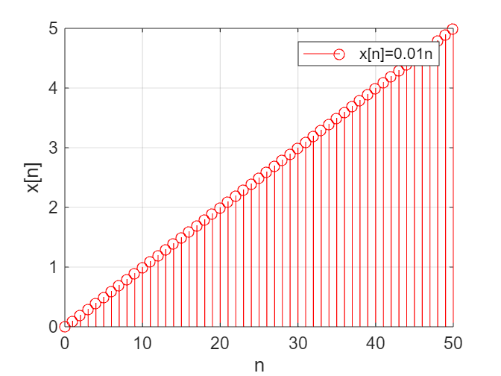
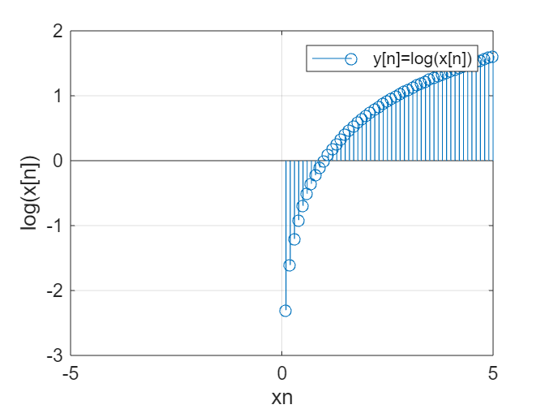
Lab result:
As x[n] approaches 0 from the positive direction, y[n] tends to negative infinity with no lower bound. Therefore, the system is unstable.

1.4d (invertible)
(d). The system given in Part (a) is not invertible
They want to prove that the system y[n] = sin((π/2)x[n]) is not invertible.
Analysis:
A system is considered irreversible if it does not have a unique inverse or if it is not possible to recover the input signal x[n] from the output y[n] without any loss of information. Let plot y[n] signal image to find out if the system have a unique inverse or not. If the system has same output at different x[n], so the system is not invertible:
clear;
clc;
% 定义 x 的范围
x = linspace(-8, 8, 1000); % 包括几个周期以显示重复性
% 计算 y
y = sin(pi/2 * x);
% 绘制函数图形
figure;
plot(x, y, 'b-'); % 绘制 sin((pi/2)*x)
title('y[n] = sin((pi/2) * x[n]) 的图形');
xlabel('x[n]');
ylabel('y[n]');
grid on;
% 通过选择 y 值，突出显示不可逆性，这些 y 值具有多个 x 解
hold on;
highlight_values = [0, 1, -1]; % 检查具有多个 x[n] 的典型值
colors = ['r', 'g', 'm']; % 不同高亮点的颜色
legends = {'sin((pi/2) * x)', 'y = 0', 'y = 1', 'y = -1'};
for i = 1:length(highlight_values)
y_value = highlight_values(i);
x_solutions = x(abs(y - y_value) < 0.01); % 查找 y 接近所选 y_value 的 x 值
plot(x_solutions, y_value * ones(size(x_solutions)), 'o', 'Color', colors(i));
% 绘制每个解点
end
legend(legends);

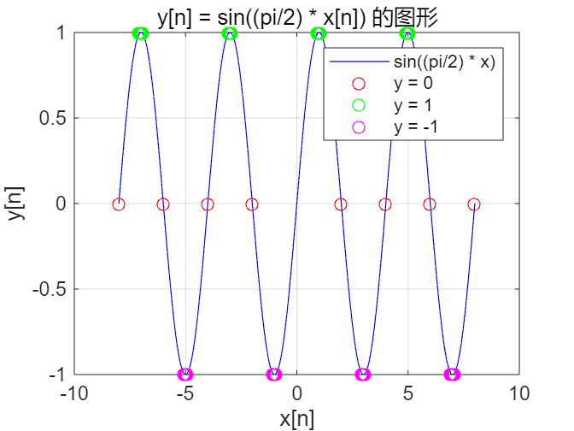

Lab result:
Since y=0 has different x[n], the system is not 1-to-1, and the input signal cannot be recognized by the output signal. So the system is not invertible.

1.5a (function)
They ask for function y = diffeqn(a, x, yn1) to compute this equation.
(a). Write a function y=diffeqn(a,x, yni) which computes the output y[n] of the causal system determined by Eq. (1.6). The input vector x contains x[n] for 0 <= n <= N - 1 and yn1 supplies the value of y[-1]. The output vector y contains y[n] for 0 <= n <= N - 1. The first line of your M-file should read function y = diffeqn(a,x,ynl) Hint: Note that y[-1] is necessary for computing y[0], which is the first step of the autoregression. Use a for loop in your M-file to compute y[n] for successively larger values of n, starting with n = 0.
Analysis:
For the function y[n] = ay[n-1] + x[n], y[-1] is necessary for computing y[0]. Suppose y [-1] is a fixed value yn1, when n=0, there is a special case, we will discuss it separately, and the rest part will do a loop in M-file to compute y[n]:
function y = diffeqn(a, x, yn1)
% 初始化输出向量
N = length(x);
y = zeros(1, N);

% 计算 y[n]，从 n=0 开始
for n = 1:N
if n == 1
y(n) = a * x(n) + yn1;
else
y(n) = a * x(n) + y(n-1);
end
end
end
Lab result:
The subfunction is written out successfully and can run smoothly

1.5b (response)
They ask us to use the function in 1.5a to figure out a = 1, y[-1] = 0, x1[n] =δ[n], x2[n] = u[n],
(b). Assume that a = 1, y[-1] = 0, and that we are only interested in the output over the interval 0 <= n <= 30. Use your function to compute the response due to xl[n] = δ[n] and x2[n] = u[n], the unit impulse and unit step, respectively. Plot each response using stem.
the corresponding y[n] image when 0 <= n <= 30.
Analysis:
The response is calculated by unit impulse signal and unit step signal. Draw an image based on the information we have:
clear;
clc;
% 定义输入信号
N = 31; % 0≤n≤30
n = 0:N-1;
x1 = [1,zeros(1,N-1)]; % 单位脉冲信号
x2 = ones(1, N); % 单位阶跃信号

% 计算响应
a = 1;
yn1 = 0; % y[-1]
y1 = diffeqn(a, x1, yn1);
y2 = diffeqn(a, x2, yn1);

% 绘制响应
figure;
subplot(2,1,1);
stem(0:N-1, y1);
title('Response to x1[n] = δ[n]');
subplot(2,1,2);
stem(0:N-1, y2);
title('Response to x2[n] = u[n]');

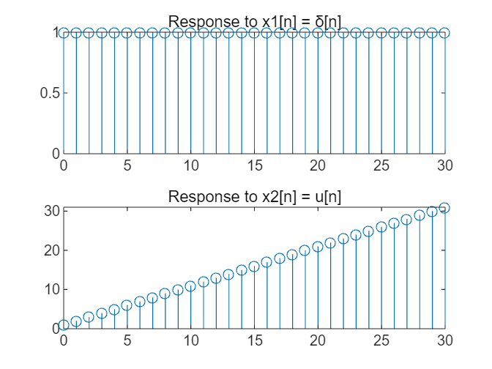

Lab result:
The upper side is the corresponding image of x1[n] =δ[n], and the lower side is the corresponding image of x2[n] = u[n].
(c). Assume again that a= 1, but that y[-1] = -1. Use your function to compute y[n] over 0 <= n <= 30 when the inputs are x1[n] = u[n] and x2[n] = 2u[n]. Define the outputs produced by the two signals to be y1[n] and y2[n], respectively. Use stem to display both outputs. Use stem to plot (2y1[n] – y2[n]). Given that Eq. (1.6) is a linear difference equation, why isn't this difference identically zero?
1.5c (image)
The question asks to make the corresponding y1[n] and y2[n] images when a = 1, y[-1] = -1, x1[n] =u[n], x2[n] = 2u[n], 0 <= n <= 30, and draw the image of 2y1[n] - y2[n], and study why it is not always 0.
Analysis:
y[n]=-1+x[0]+x[1]+…… +x[n], x2[n]=2x1[n]. So 2y1[n] - y2[n]=-1. Draw the desired image:
n=0:30;
x1n=ones(1, N);
x2n=2*ones(1, N);
y1n=diffeqn(1,x1n,-1);
y2n=diffeqn(1,x2n,-1);
y3n=2*y1n-y2n;
stem(n,y1n,'r')
grid on;xlabel('n');
ylabel('y[n]');
legend('y1[n]');
stem(n,y2n)
grid on;
xlabel('n');
ylabel('y[n]');
legend('y2[n]');
stem(n,y3n,'g')
ylim([-5,0]);
grid on;
xlabel('n');
ylabel('y[n]');
legend('2*y1[n]- y2[n]');

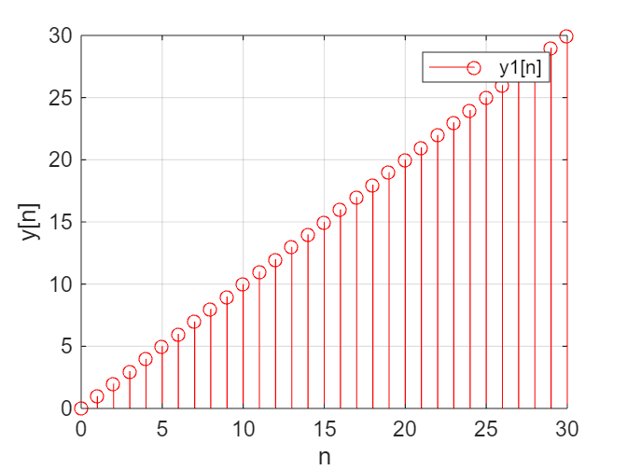
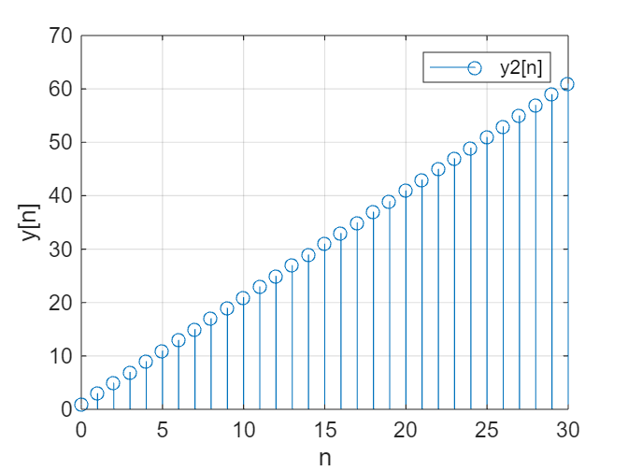
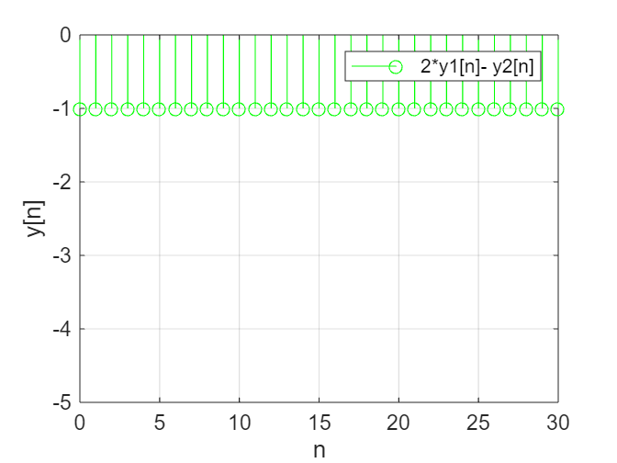

Lab result:
Since 2y1[n]-y2[n]=2*(-1+x1[0]+x1[1]+... +x1[n])-(-1+x2[0]+x2[1]+…… +x2[n]), x2[n]=x1[n]. So 2y1[n] - y2[n]=-1. It matches the image.

Note: Please indicate meaning of the symbols in all expressions. Please indicate the coordinate and unit in all figures.
Experience
- When using conditional statements, we misunderstand the bounds of the array, and we correct the error by analyzing it line by line.

- The use of some functions is not very skilled, we read the data to understand these functions.

- Various properties of the function system are deeply understood.

Score | 100/100

字体：英文Times new Roman；

